SECURITY COUNCIL: ADVANCING INTERNATIONAL PEACEKEEPING REFORMS IN THE MIDST OF CURRENT ONGOING CRISES

Background and Historical Reference:

In the nearly 80 years since the creation of the United Nations, UN Peacekeeping has evolved significantly as a tool of international crisis response. There are currently 12 peacekeeping operations led by the Department of Peace Operations throughout the global community. In recent years UN Peacekeeping missions have been deployed to extremely volatile and complex situations, thus the global need for a strong and organized peacekeeping response has become more and more necessary, and the Peace Operations Department has struggled to meet these demands. The implementation of peacekeeping mandates is often hindered by slow, unresponsive service delivery, micro-management by governing bodies, a trust deficit with Member States and with staff, inadequate resourcing of and ineffective implementation of mandates and a lack of transparency and accountability. 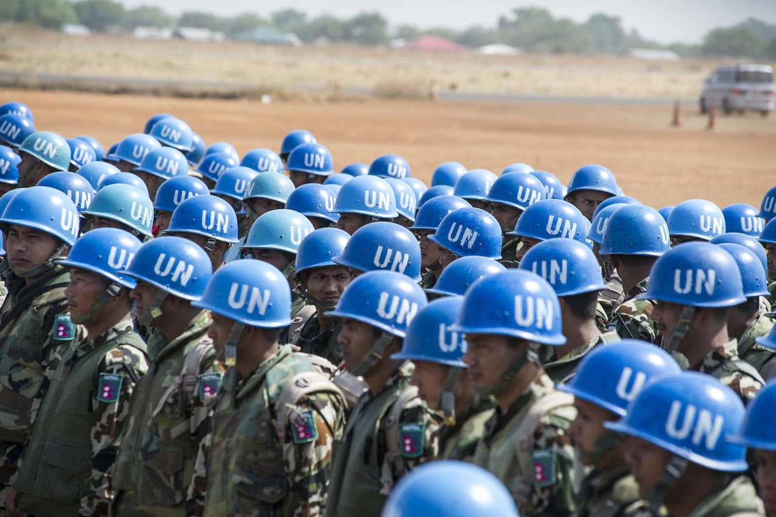

Peacekeeping is an incredibly necessary tool of international crisis response. Yet peacekeeping faces several disadvantages that hinder its ability to respond to international crises. Peacekeeping mandates are often lacking in specific political solutions, the often lack focus, and clear priorities. These challenges have caused some peacekeeping missions to bog down and a lack of clarity to lead to extreme confusion in the mission’s direction. For example, The United Nations Mission for the Referendum in Western Sahara (MINURSO) was established by Security Council resolution 690 of 29 April 1991. The stated purpose of MINURSO is to prepare Western Sahara for an eventual referendum for the people to determine whether or not Western Sahara will form a free state or be incorporated into Morocco. However, over 3 decades have passed since MINURSO was established. There has still not been a referendum. There is no indication that there ever will be. The geopolitical situation has changed entirely since 1991. The force of nearly 500 peacekeepers in Western Sahara are deployed to a very tense political environment with no clear mandate. Such as an example of how the UNSC must respond to outdated peacekeeping missions and establish clearer guidelines for future missions.

On August 16, 2021, The UN Secretariat established the Declaration of Shared Commitments. The declaration received over 150 endorsements from relevant member states and provides a shared roadmap for strengthening peacekeeping. Success depends on Member States and the UN Secretariat working actively to implement their commitments. Former Secretary General Ban Ki-Moon established a “High Level Panel on UN Peace Operations in 2014. The organization assessed the state of Peace operations and emerging needs of the future. The Panel considered the issues facing UN Peace missions around the globe, including the changing nature of conflict, evolving mandates, good offices and peacebuilding challenges, managerial and administrative arrangements, planning, partnerships, human rights and protection of civilians. The review encompasses both UN peacekeeping operations as well as special political missions , which are referred to collectively as “UN peace operations.”

Advancing the Readiness and Capability of Peacekeeping Forces

As crises arise and the United Nations Security Council is often tasked to deploy peacekeepers to stabilize conflict zones, this is a costly and time consuming process. In March 2000, the Secretary-General appointed the Panel on United Nations Peace Operations to assess the shortcomings of the then existing system and to make specific and realistic recommendations for change. This report was known as the Brahimi Report. The Brahimi Report found renewed political commitment on the part of Member States; significant institutional change; and increased financial support are the necessary and lacking issues facing the peacekeepers. In order to increase the capability of the UN’s peacekeeping force. Delegates must consider how to improve the UN’s response to each of the main issues. A significant component of the Peacekeeper’s lack of professional readiness is that member states have not contributed the necessary finances, or contributed to necessary institutional changes. Delegates must consider how to incentivize member states into making these contributions.

A major question facing the United Nations Security Council is how to properly respond to potential international crises quickly enough and with significant troop quality. Some scholars suggest that an international ready peacekeeping force is necessary to essentially serve as a military wing of the UNSC to quickly respond to crises to streamline responses to international crises. While major member-states consider this extremely counterproductive to their interests. A major issue facing peacekeeper quality is training. There are some mission specific training programs for UN Peacekeepers, however, many Peacekeepers never receive any extensive training beyond the basic training offered by their home nation’s military. This has often led to an immense issue of Peacekeepers struggling to competently do their jobs on mission sites. Oftentimes Peacekeepers have even been responsible for human rights abuses. The United Nations discovered that over 150 credible allegations of sexual violence where committed by troops within the United Nations Organization Mission in the Democratic Republic of the Congo (MONUC). However, to date not even one UN Peacekeeper has been tried for allegations of violence. Delegates in the committee must consider how to improve troop quality to prevent violations of the law in the future, how to improve troop quality to conduct the mission properly, and how to deploy peacekeepers quickly in a way that respects each member’s national interests.

A major ongoing issue in Peacekeeping readiness is specifically related to an overall lack of leadership, preparedness and integration of Peacekeepers into various Peace Missions, and an existing risk-averse culture within the leadership of UN Peacekeeping missions. Major General Cammaert of the Dutch Army, and former military advisor to the UN Secretary General, points to all of these as a major component of the UN to prevent the killings of multiple civilians during the Juba Massacre in South Sudan in 2016. During the attack South Sudanese troops launched an attack on a refugee camp in Juba only one kilometer from the UN headquarters. “Multiple requests were made to stand up a quick reaction force to respond but each UN mission contingent turned down the request, indicating their troops were fully committed,” Cammaert wrote. Cammaert also argued that peacekeepers during the massacre did not operate under a unified command. Peacekeepers from the four troop contingents (China, Ethiopia, Nepal, and India) received multiple conflicting orders. Ultimately the UN underused over 1,800 infantry troops at the headquarters in Juba. If these troops were properly used, it is very possible that the massacre at the refugee camp could have been stopped. Even now the UN Mission in South Sudan does not conduct proper foot patrols, peacekeepers do not make genuine efforts to detect perpetrators of sexual or physical violence, and peacekeepers do not engage with the community to provide a sense of security. Delegates within the United Nations Security Council must consider in what ways peacekeeping missions can be streamlined, and held accountable to ensure that they properly respond to the crises at hand in real time and with professionalism.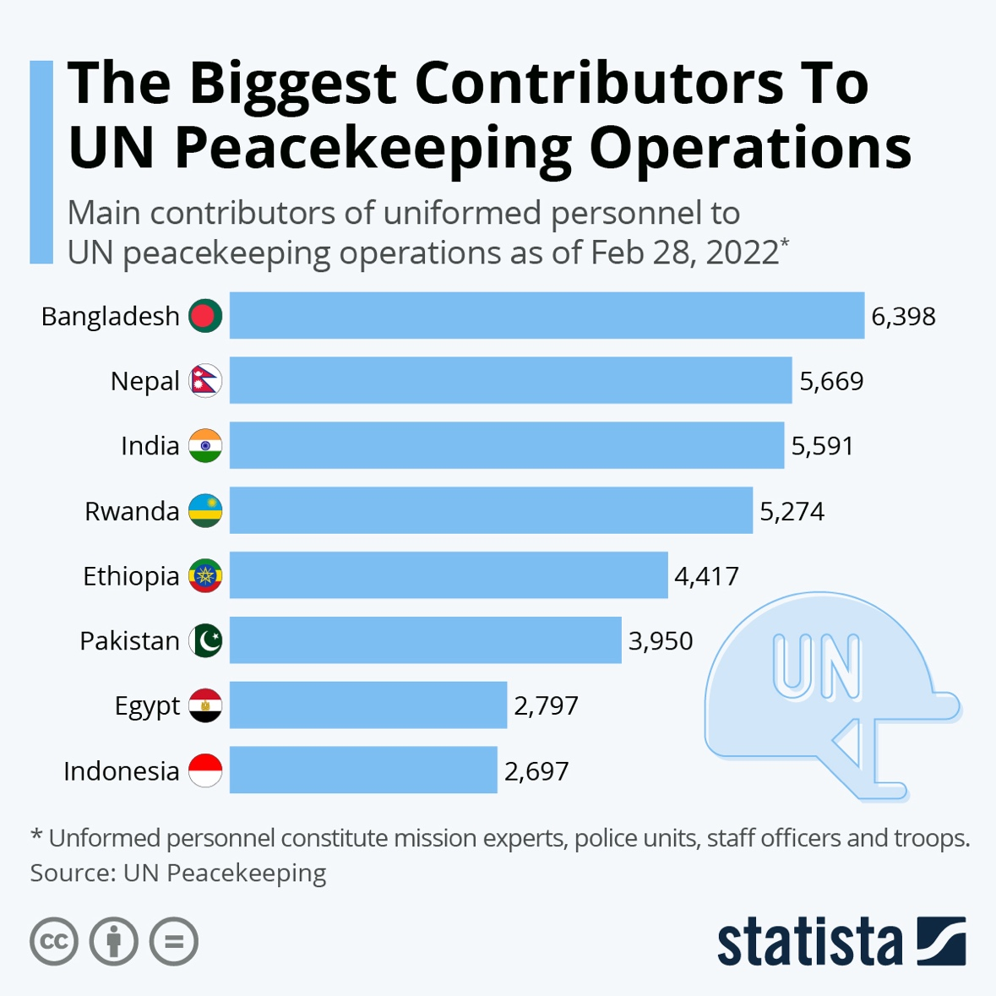

Establishing and Re-establishing Mandates for Future and Present Peacekeeping Missions

A major failing of peacekeeping missions in the past and present has been the failure of the United Nations to provide, establish, and maintain a clear and organized mandate for Peacekeeping Missions. For example in 2011 The United Nations Security Council established The United Nations Mission in the Republic of South Sudan (UNMISS.) UNMISS was first established as a peacekeeping mission to consolidate peace and security and pave the way for development. Currently UNMISS has 19,101 authorized uniformed personnel as a part of the mission. Following the outbreak of the Sudanese Civil War in 2013, the United Nations reprioritized UNMISS’ mandate to include the protection of civilians, human rights monitoring, and support for the delivery of humanitarian assistance and for the implementation of the Cessation of Hostilities Agreement. As the Civil War in South Sudan ceased in 2020, the mission may yet again have to update its mandate. Delegates must consider how to streamline the process of updating various UN peacekeeping missions mandates in a sensible way to prevent the waste of UN resources and to prevent the mission from operating in a disorganized fashion. 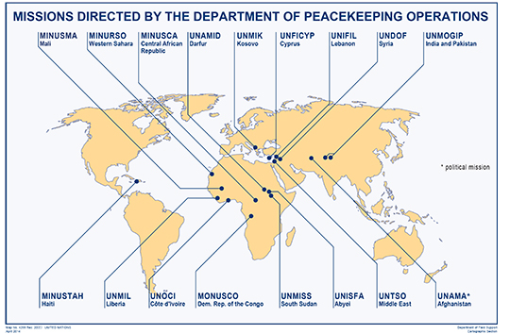

Currently major humanitarian crises are becoming more and more prominent around the world. As human rights and humanitarian crises explode in places such as Venezuela, Peru, Yemen, the Northern Triangle of Central America, Eastern Europe, Ethiopia, and Myanmar and so on, delegates must consider how various peacekeeping missions must organize and establish their mandates to produce efficiency and respond to various crises. As humanitarian crises worsen in certain regions, delegates must determine what are the conditions and specific parameters to justify UN involvement. Delegates must also consider at what parameters should certain Peacekeeping missions be disbanded. A streamlined set of guidelines for the international community to follow is critical for the success of future and current missions.

Currently Peacekeeping missions throughout the world have a number of specific priorities to justify their mandates, these usually include providing humanitarian aid, monitoring human rights conditions, monitoring cease fires/peace agreements, and protecting civilians in conflict zones. However, there is an expanded debate internationally as to if there are other areas that should fall within a Peace Mission’s priorities. For example as the Venezuelan Refugee Crisis has exploded within the last 5 years due to social issues, political repression, and economic hardship, the world has seen over 7 million Venezuelans migrate to other neighboring nations. Currently there is no UN Peace Mission in South America to assist in the maintenance of humanitarian conditions for migrants. While Peace Missions to address various migrant crises have been implemented in past policies, they are uncommon. Delegates must determine what, if any, additional issues justify a peace mission. Delegates must also consider what issues do not justify a peace mission and how to address grievances between member states who disagree on if/how a peace mission is justified.

The Role of Member States and Regional Organizations in Peacekeepering Operations

Various regional and multilateral entities throughout the international community have been involved in peacekeeping operations throughout the globe. Delegates in the committee must consider what standards, if any, should apply to regional organizations that operate peacekeeping missions and also to what role these organizations may function in tandem with the United Nations. For example, The African Union Mission in Sudan (AMIS) was an AU peacekeeping force operation in Western Darfur to provide peacekeeping aid during the Darfur conflict. In 2004 under United Nations Security Council Resolution 1564, AMIS was directed to coordinate with the UN Mission in South Sudan. However, the parameters of cooperation were not clearly defined. A more sizable and better equipped UN peacekeeping force was proposed for 2006. However, the Sudanese government was severely opposed to the intervention of UN forces operating in the country, therefore it was not implemented. As the situation in Darfur deteriorated and UN Peacekeepers were not deployed, AMIS’ mandate was extended into 2006. In this situation, the peacekeeping force implemented by the African Union was able to somewhat operate to fill gaps until the UN force was able to be implemented. Delegates are tasked with the responsibility to determine the role of regional bodies and their peacekeepers. Delegates must consider to what extent and what mandate regional bodies’ peacekeeping missions can operate, and what guidelines they must operate under. Delegates must also consider how regional bodies’ peacekeeping missions can work in tandem with the UN and various UN peace missions.

Independent member states have also at various times taken action to support their own peacekeeping operations in support of various UN peacekeeping missions. The international community must decide to what extent this is permissible, and to what the parameters these member states should abide in terms of coordination with various UN missions. For example, from 2002-2015, the French Armed Forces launched a peacekeeping operation known as Opération Licorne in support of the United Nations Operation in Côte d'Ivoire. French Armed Forces had been stationed in the country following the outbreak of the Ivorian Civil War. The troops' main mission was to support the United Nations peacekeeping mission and to ensure the security of French and foreign nationals. The French Army has also been involved in multiple interventions that they claim to be peacekeeping operations in other African nations such as Operation Sangaris in the Central African Republic. Throughout the operation the French Army aimed to contribute to peacekeeping operations by engaging in hostilities against warring factions in the Central African Civil Conflict. The French viewed Operation Sangaris as a major success due to the French claims to have completed the mission to stop fighting in CAR and contributed troops to the UN peace mission. Detractors of the mission claimed that French operations in the CAR amounted to nothing more than neo-imperialism in former French colonies. Detractors of the French mission and other former colonial powers’ contributions to peacekeeping missions in former colonies heavily criticize such military contributions. Delegates must properly analyze the role of specific powers’ militaries to operate in tandem with various international peace missions. Delegates must also analyze from their country's perspective, to what extent certain powers should/should not be involved in unilateral efforts to build peace. Certain former colonies may take issue with such missions, while others may view such missions as vital to their national security interests.

Guiding Questions:

- What are specific parameters that should be included in the mandate of a Peacekeeping mission?
- How can the international community ensure that Peacekeepers are properly trained, operationally ready, and able to conduct the mission efficiently?
- How can the international community guarantee that state actors in a conflict zone will abide by the Peacekeeping Mission’s mandate?
- In the case that (a) Peacekeeper(s) commits a violent crime, what are the ways that individuals should be held accountable? Would the responsibility of accountability fall on the nation of origin, the United Nations, the nation where the crime was committed, or another party?
- How can Peacekeepers in the field receive organized directions that clearly define orders in the field?
- What are the expectations of Peacekeepers in the field to intervene in conflict situations to protect civilians in cases of violence?
- To what extent should regional organizations such as the African Union be involved in their own peacekeeping missions and in the support of United Nations Peacekeeping Missions?
- What should be the framework and limitations for nations that undertake unilateral peacekeeping missions, and how should these missions function in tandem with the UN?
- How can international peacekeeping missions, especially those that are directed by specific nations to support UN missions, operate within the confines of international law and the principles of national sovereignty?
- What are the legal frameworks, standards, and guidelines that should apply to international peacekeeping missions?
- What are the possible conflicts of interest and concerns that former colonial powers may have when launching peacekeeping efforts in their former colonies? Is there a way to mitigate these concerns?
- How can peacekeeping missions from the UN, regional bodies, and specific nations work in tandem to tackle issues of transnational terrorism?
- What are the standards and guidelines that international peacekeeping missions must abide by in order to effectively monitor ceasefires and peace agreements when they are deployed in the aftermath of a war or civil conflict?
- What are ways to streamline the command structure of international peacekeeping missions to ensure that peacekeepers respond to immediate crises swiftly?
- Should the international community consider a standing military force designed to respond to certain crises with an increased degree of swiftness? Would this violate certain nations’ national interest? Would this violate international sovereignty?
- What are certain areas of the world, and certain conflict zones that the committee should suggest the deployment of future peacekeeping missions?
- What are currently peacekeeping missions that need their mandates updated, and how should the international community update the mission to modernize its goals and priorities?

