SYRIAN CRISIS BACKGROUND GUIDE: SYRIAN RECONSTRUCTION
DIRECTOR: TYRA VOLTAIRE

*As this an ongoing real world crisis, please only refer to the dates and information provided in this background guide
Historical Context of the Crisis
After the collapse of the Ottoman Empire in 1918, Syria fell under French control as part of the League of Nations Mandate system, based on the secret Sykes-Picot Agreement. The Sykes-Picot Agreement established British and French control zones across territories that encompass modern-day Israel, Lebanon, Syria, and Palestinian territories. This period was marked by growing nationalist resistance, most notably the Great Syrian Revolt of 1925–27. Syria proclaimed independence in 1941, with full sovereignty recognized in 1945, and the last French troops departing in 1946.The post-independence era was politically unstable, with multiple coups between 1949 and 1963. A brief union with Egypt as the United Arab Republic occurred from 1958 to 1961 but ended with a Syrian military coup. Since 1970, Syria has faced a long reign under Hafez al-Assad. This was achieved through a coup known as the “Corrective Movement.” Under this movement, al-Assad had a long authoritarian rule until 2000. This was achieved through internal repression, regional conflict, and abuse of Syrian citizens. Following the death of Hafez al-Assad, Bashar al-Assad succeeded his father. Bashar initially promised reform but soon faced large protests against his regime. The protests soon became a civil war. The internal conflict caused outside influences, such as Russia and Iran, to support Assad, while the United Nations firmly denounced the regime's extreme violations of human rights.
In 2010 Arab spring occurred. It was characterized by a wave of social uprisings that demonstrated civilians wanted their voices to be heard. Sparked by demands for political reform, economic justice, and an end to authoritarian rule across the Arab world,it quickly spread from Tunisia to Egypt, Libya, Yemen, Bahrain, and Syria. In Syria, the Arab Spring began in early 2011, with peaceful protests calling for democratic reforms, but the government turned the demonstrations into a nationwide uprising. As violence escalated, the conflict transformed into a complex civil war involving sectarian tensions, regional powers, and extremist groups. Foreign actors, including Iran, Russia, Turkey, and various Gulf states, intervened, transforming Syria’s civil war into a major proxy war. This left catastrophic damage to the region, resulting in the modern day discombobulated Syria.
In 2012, the UN General Assembly adopted a resolution A/RES/66/253 condemning the Assad regime for "widespread and systematic violations of human rights" and called for the withdrawal of Syrian forces from besieged towns and cities. Activists and protesters were oftentimes the targets of Syrian forces, inciting more civil unrest. In addition, Alawites searched cities in pursuit of Assad opposition in an effort to permanently silence those who did not conform.The Assad family, which has ruled Syria since 1971, belongs to the Alawite religious group. Although Alawites are a minority in Syria (about 10–15% of the population), they hold a lot of power in the government, military, and security forces.
On 8th December 2024, the Assad regime collapsed during a major offensive by opposition forces. The fall of the regime was seen as a significant geopolitical shift in the region, impacting Iran's influence and altering the dynamics of the Syrian conflict. The Assad regime's history is marked by authoritarian rule, brutal repression, and significant regional conflicts, leaving a lasting impact on Syria and the broader Middle East.
Currently, Syria is being led by Ahmad al-Sharaa, the leader of the opposition forces that toppled Assad's rule. Sharaa has faced global scrutiny because of his previous membership in al-Qaeda. In 2013, while still maintaining ties with al-Qaeda, Sharaa named his intent for Syria to exist as a fundamentalist Islamic state, stating that religious minorities would have no room in the country. Since then, however, Sharaa has appeared to pull back from this intent, announcing in 2015 that he does not wish to target religious minorities or to create conflict with Europe or the United States.
In his first speech as president, Sharaa outlined these goals: bringing peace to Syria while pursuing “the criminals [members of the Assad regime] who were eager to taste Syrian blood”; accomplishing the territorial unity of Syria in its entirety; building strong state institutions based on merit and justice; and stabilizing the economy in order to improve living conditions and restore basic services.
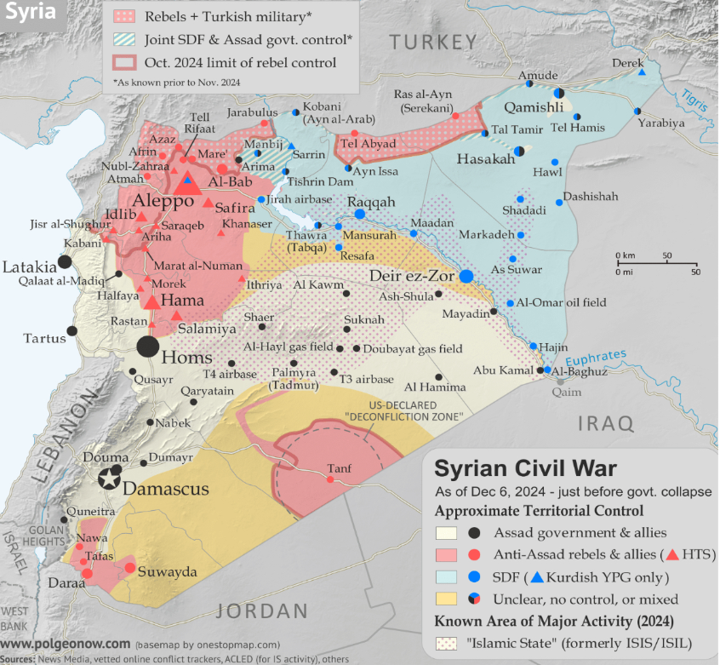Regional Control – December 2024

According to PolGeoNow, as of December 2024, the Syrian government collapsed. Rebel forces spread out to assert themselves as the new authorities across most of the country. Turkish-backed rebels competed with the Kurdish-led SDF for control of the north and east, while Israel sent troops towards Damascus, and the Islamic State (ISIS/ISIL) attempted a resurgence in the central desert.
Syria is split into many islamic sects. Historically, under Ottoman and post-Ottoman rule, Sunnis formed much of the political, merchant, and urban elite. Only ten years ago Sunni rebels and jihadist forces controlled much of the eastern and central countryside, which by that point was almost entirely populated by Sunni Arabs.
The Alawites beliefs originated from a branch of Twelver Shia Islam, but evolved into a highly distinct tradition. Their visibility and political importance rose significantly during and after the French Mandate. Once empowered by the Assad regime, many Alawites now face reprisals from rebel factions and displaced Sunni populations who suffered under Assad's rule. Revenge attacks occurred killing over 1,000 people, including hundreds of Alawites, as power dynamics in Syria shift violently.

The Druze are primarily concentrated in the southern region of modern-day Suwayda. Under the French Mandate, the Druze were given a semi-autonomous state, and they played a major role in the Great Syrian Revolt of 1925–27, which was led by the Druze leader Sultan al-Atrash. The Druze community is deeply divided: some factions are willing to work with the central government, while others are wary, especially given past grievances and concerns for their safety.

ISIS emerged in Syria around 2013–2014, exploiting the chaos of the civil war to seize territory in northern and eastern regions. The group imposed a brutal interpretation of Sharia law, committing mass executions, and violent crimes towards innocent civilians. Its presence worsened Syria’s humanitarian crisis and intensified sectarian tensions between Sunni, Kurdish, and minority communities. International coalitions, along with Syrian Democratic Forces and local militias, gradually recaptured most ISIS-controlled areas by 2019, though the group remains active in isolated regions.

Historically marginalized under both Ottoman and post-independence Syrian governments, Kurds were denied citizenship for decades, limiting their political and economic rights. During the Syrian civil war, Kurdish forces established autonomous self-administration in parts of northern Syria, emphasizing local governance, gender equality, and secularism. This directly contradicted many traditional ideals of the Islamic state, creating social tensions between many sects. Often supported by the U.S.-led coalition, they played a key role in fighting ISIS, which increased their military and political influence. Today Kurds face ongoing challenges, which include Turkish military interventions and tensions between lingering Assad supporters.
Past Actions of the United Nations

Since 2011, the United Nations has provided humanitarian aid, diplomatic initiatives, and Security Council resolutions. In addition to this, the UN has provided reports of the Independent International Commission of Inquiry on the Syrian Arab Republic.
According to the report provided in November 2011, it interviewed 223 victims and witnesses of alleged human rights violations, including civilians and defectors from the military and the security forces. In the present report, the commission documents patterns of summary execution, arbitrary arrest, enforced disappearance, torture (including sexual violence), as well as violations of children’s rights. The United Nations has been notable for its statements against these atrocities.
In the first statement published by the Chair of the Independent International Commission of Inquiry on the Syrian Arab Republic, it stated: “...The Commission cannot overemphasize the need to halt the suffering of civilians in Syria. The Government must put an immediate end to the ongoing gross human rights violations, initiate independent and impartial investigations of these violations and bring perpetrators to justice. We strongly support the call of the League of Arab States for a monitoring presence in Syria...”
While oftentimes UN resolutions are merely suggestions , past resolutions and committees have been somewhat effective.The Office for the Coordination of Humanitarian Affairs (OCHA) plays a central role in organizing and coordinating the UN and NGO humanitarian response. It is because of this committee that Syrians are able to receive humanitarian aid and food in more secluded areas. It also manages regional offices in Amman, Gaziantep, and Damascus to facilitate aid delivery and humanitarian access across conflict lines and borders.
According to its website the UN Office of the Special Envoy for Syria has been at the forefront of political diplomacy and peace building efforts. Initially led by Staffan de Mistura, and currently by Geir O. Pedersen (since 2016), the office has facilitated key diplomatic processes such as the Geneva talks and the formation of the Syrian Constitutional Committee, while also advocating for the implementation of UN Security Council Resolution 2254 (2015), which outlines a political roadmap including constitutional reform and free elections.
Unfortunately, while many United Nations leaders found this successful, the Syrian Democratic Council (SDC), rejected the declaration, criticizing it for granting unchecked presidential authority, failing to protect minorities, and preserving authoritarian structures

Crisis in Depth
Many Syrians are distrustful of the current government, fellow countrymen, and countries previously allied with the Assad regime. Many were not safe in hospitals, places of worship, or even their homes. To rebuild the trust of the people may be the largest task.

The Syrian public often finds co-conspirators of the Assad regime and those with negative interest in the region to be persona non grata.The 2019–2020 Arab Opinion Index found overwhelmingly negative views of foreign policies of the United States (58%), Iran (58%), and Russia (41%) within the broader Arab public, including Syria. Syrians often view foreign actors as having ulterior motives or causing suffering rather than offering real help.
The problems faced in Syria are not just of a political nature. In recent months, there has been a rise in religious discrimination against secular religions in the region. The patterns of violence and revenge today are deeply rooted in historical policies (colonial and state-level) that have institutionalized sectarian division.

Furthermore, Syrians face the effects of climate change, food insecurity, and rapid urbanization.
It is the responsibility of the nations gathered, to begin reconstruction efforts in Syria that do not violate the sovereignty of its nation, cause further destruction, or harm its citizens. It is important not to implicate these actions without political reform so as to avoid a repetition of the prior government.

Underlying issues
In addition to the social and political conditions, Syrians also face the effects of climate change, food insecurity, and rapid urbanization. Years of severe drought, rising temperatures, and depleting water resources have devastated agricultural regions, especially in the northeast. This has forced many rural families to migrate to cities even before the civil war began. The war exasperated this issue, because an increasing number of Syrians fled to cities away from their rural regions. The civil war destroyed agricultural infrastructure, including irrigation systems, farms, and storage facilities. Furthering this concern, the displacement of millions of people disrupted local food markets and labor availability for farming. Humanitarian organizations estimate that over half of Syria’s population is currently facing high levels of food insecurity, relying heavily on aid to survive, making recovery and long-term stability extremely challenging. At the beginning of this century Syria had a very high birth rate leading to a larger population. Only about half the country’s land can support its population, and about half the population is concentrated in the country’s urban centers. These combined struggles intensify Syria’s humanitarian crisis, making access to food, water, and basic services a scarce commodity for most of the population.

Questions to consider
- What is our national interest in Syria's reconstruction?
- Historically, has your country aided or funded the war crimes that occurred in Syria?
- Do the citizens of Syria trust your nation?
- At what cost does Syria's reconstruction come to your own nation?
- Do current policies build a Syria that is dependent on foreign aid or a future for an independent nation?
- Does your nation have pre-existing interest with Syria?
- Will the country seek support for Syria in the International Court of Justice?
- How will asylum-seeking Syrians be benefited during the reconstruction?
- Do the proposed plans build upon the pre-existing United Nations framework?
- Should the new Syrian state be secular or Islamic (moderate or otherwise)?
- How will this affect minority groups (Kurds, Christians, Jews, and Animists)?
- Can oil export revenues be directed toward reconstruction?
- What model of reconstruction should Syria pursue — traditional, or renewable energy-based?
- How can Syria rebuild food production capacity, and should food security be a top priority?

Works Cited
"Ahmed al-Sharaa and Hope for the Future of Syria." Glimpse from the Globe, https://www.glimpsefromtheglobe.com/. Accessed 25 July 2025.
"Ahmed al-Sharaa | Syrian Civil War, al-Qaeda, & Bashar al-Assad." Encyclopædia Britannica, https://www.britannica.com/. Accessed 25 July 2025.
"Conflict in Syria." Global Conflict Tracker, Council on Foreign Relations, https://www.cfr.org/global-conflict-tracker/conflict/conflict-syria. Accessed 25 July 2025.
Hamidé, Abdul-Rahman, Polk, William Roe, Scullard, Howard Hayes, Commins, David Dean, Ochsenwald, William L., Irvine, Verity Elizabeth, Smith, Charles Gordon, Gadd, Cyril John, Salibi, Kamal Suleiman, Hourani, Albert Habib. "Syria". Encyclopedia Britannica, 19 Nov. 2025, https://www.britannica.com/place/Syria. Accessed 19 November 2025.
"History of Syria." Encyclopædia Britannica, https://www.britannica.com/. Accessed 25 July 2025.
"Joint Application Instituting Proceedings." International Court of Justice, https://www.icj-cij.org/. Accessed 25 July 2025.
"Mapping Who Controls What in Syria." Al Jazeera, 6 Dec. 2024, https://www.aljazeera.com/news/2024/12/6/mapping-who-controls-what-in-syria. Accessed 25 July 2025.
"Political Geography Now: Syria." Political Geography Now, https://www.polgeonow.com/search/label/syria. Accessed 25 July 2025.

RAND Corporation. Research Report RRA2287-1. “The Prisoner Dilemma.” RAND Corporation, 2022. (rand.org)

"Syria Summary." Encyclopædia Britannica, https://www.britannica.com/. Accessed 25 July 2025.
"Syria: Which Countries Have Been Involved in the War and Why?" Sky News, 15 Mar. 2021, https://news.sky.com/story/ten-years-of-war-in-syria-why-the-conflict-began-who-was-involved-and-the-consequences-12244607. Accessed 25 July 2025.
"Special Envoy for Syria." United Nations Department of Political and Peacebuilding Affairs, https://dppa.dfs.un.org/en/mission/special-envoy-syria. Accessed 25 July 2025.
"The Fractured Relationship of the Alawite Community and Assad Regime." Atlantic Council, https://www.atlanticcouncil.org/. Accessed 25 July 2025.
"Who Are the Major Combatants in the Syrian Civil War?" Encyclopædia Britannica, https://www.britannica.com/event/Syrian-Civil-War. Accessed 25 July 2025.
"Security Council Briefed on Syria Political, Humanitarian Issues." United Nations Press, 2024, https://press.un.org/en/2024/sc15772.doc.htm. Accessed 25 July 2025.
Wilks, Alexandra. "Kurdish-Led Syrian Group Rejects Islamist Authorities’ New Constitution Framework." Reuters, 14 Mar. 2025, https://www.reuters.com/world/middle-east/kurdish-led-syrian-group-rejects-islamist-authorities-new-constitution-framework-2025-03-14/. Accessed 25 July 2025.
Image Citation:
“2024-12-06_syria-war-map-2024-territory-control-rebels.png.” Political Geography Now, https://www.polgeonow.com/2024/12/syria-war-map-2024-territory-control.html. Accessed 25 July 2025.

