Natural Resources for Sustainable Development
Southwest Florida Model United Nations, 2026
Joint UNEP/UNDP Committee

“A world powered by renewables is a world hungry for critical minerals. For developing countries, critical minerals are a critical opportunity – to create jobs, diversify economies, and dramatically boost revenues. But only if they are managed properly. The race to net zero cannot trample over the poor. The renewables revolution is happening – but we must guide it towards justice.”

UN Secretary-General António Guterres

Background Guide
The global transition from fossil fuels to renewable energy is transforming not only how the world produces power, but also how political authority, economic development, and strategic competition are organized internationally. As states seek secure access to lithium, cobalt, copper, nickel, and rare earth elements, control over renewable resources has become one of the defining geopolitical challenges of the 21st century.
In earlier eras, energy politics revolved around oil. For much of the 20th century, the Persian Gulf functioned as the central node of the global energy system. One of the defining doctrines of this period was the U.S. Carter Doctrine (1978), which declared that any interruption of oil flows from the Gulf would be viewed as a threat to U.S. national security interests and could prompt military intervention. Energy security was thus synonymous with oil security.
Today, that geography is shifting.
Renewable energy systems depend not on oil fields, but on access to critical minerals. As a result, new regions now occupy strategic importance: lithium reserves in Argentina, Bolivia, and Chile; cobalt in the Democratic Republic of the Congo; China’s dominance in rare earth processing; and copper and nickel across Latin America, Southeast Asia, and Africa. Control over renewable infrastructure and mineral supply chains increasingly shapes state power, trade relationships, and development prospects.
Below is a table of the key minerals associated with the transition to renewable energy.

Mineral/Material | Primary Uses | Key 2025 Issues
Lithium | EV batteries; grid storage | Supply growth vs. permitting; brine water impacts; processing bottlenecks
Copper | Transmission, motors, wiring | Large absolute volume needs; new mine timelines; community consent
Nickel | High‑energy batteries | Chemistry shifts; Class 1 vs Class 2 supply; ESG concerns
Cobalt | Batteries; superalloys | DRC concentration; labour/rights; reduction via new chemistries
Graphite | Anodes for Li‑ion batteries | Refining concentration; diversification; synthetic vs natural
Rare Earths (Nd, Pr, Dy, Tb) | Permanent magnets (EVs/wind) | Separation/magnet supply; recycling; substitution R&D
Additionally, here is a glossary that can help delegates navigate this issue: Critical Minerals: Minerals essential to energy‑transition technologies with potential supply‑security risks.
Rare Earth Elements (REEs): A group of 17 elements vital for high‑performance magnets in EVs, wind turbines, and electronics.
Processing/Refining: Industrial steps that turn mined ore or brine into materials used in batteries, magnets, and conductors.
Resource Nationalism: Policies asserting national ownership/benefit from resources via taxes, royalties, state participation, or export rules.
Circular Economy: Designing products, recycling, and materials recovery to reduce primary mining needs.
Just Transition: Ensuring the benefits and burdens of the energy transition are distributed fairly across countries and communities.

Competing Energy Systems and Emerging Blocs
The global political economy is now being reorganized around two distinct energy strategies.
The United States, particularly under Donald Trump, has sought to consolidate its position as a major exporter of fossil fuels, presenting oil and gas as engines of growth, energy independence, and geopolitical leverage. This model emphasizes continued hydrocarbon extraction, resistance to climate governance, and alignment with existing petro-states. Fossil fuels remain instruments of both economic expansion and diplomatic coercion.
China, by contrast, has pursued a long-term strategy centered on renewable industrial dominance. Since Xi Jinping’s rise to power, China has invested heavily in vertically integrated supply chains—from mineral extraction to battery production, electric vehicles, and solar manufacturing. This outward expansion has been pursued under the Belt and Road Initiative and framed rhetorically as “South–South cooperation.”
China presents itself as a development partner rather than a traditional imperial power, frequently invoking its “century of humiliation” under Western domination. Critics, however, point to concerns over debt dependence, asymmetrical contracts, and environmental consequences in partner countries. The dispute is not merely ideological: it centers on whether China’s model represents development partnership or a new configuration of dependency.
Rather than a smooth energy transition, delegates must confront the reality of energy bipolarity: one bloc doubling down on hydrocarbons, another racing toward industrial dominance in renewables.
Delegates might note that energy transitions are historically associations with the emergence of new hegemonic powers - states powerful enough to organize the international political system in terms of their values and interests, as the following graph illustrates:
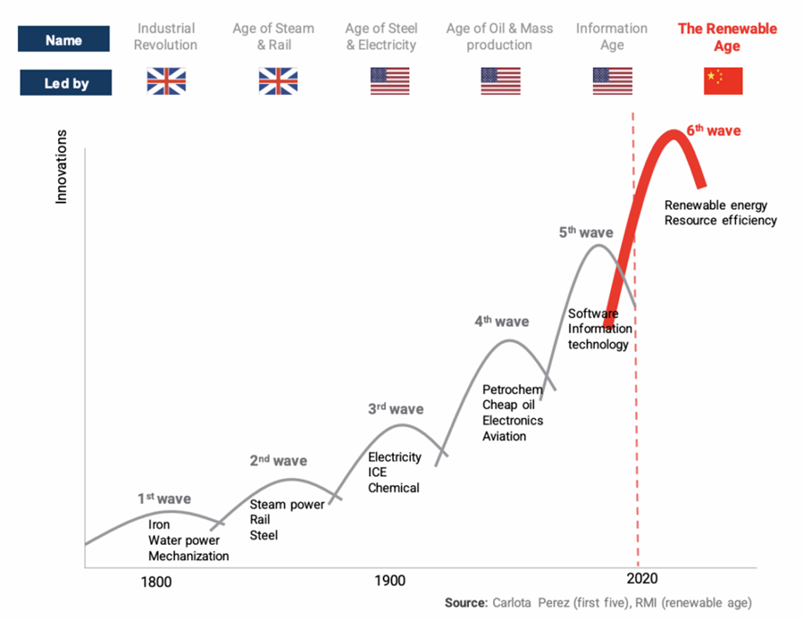
What can be done to reduce or at least channel geopolitical competition around energy resources? Writing for the World Economic Forum, Kaiser Kuo avers that geopolitical competition can spur technological innovation. Perhaps she is right: faced with restricted access to the advanced semi-conductors imposed by the Biden administration, China nonetheless produced the powerful artificial intelligence model, Deep Seek.
We might distinguish between this and low intensity conflict between China and the United States, which may well revolve around attacks on the energy systems and supply chains that increasingly sustains each of these states. All of this would constitute the weaponization of economic interdependence - an increasingly common phenomenon within a world of escalating geopolitical tensions. The thought here is that where economic interdependence was once thought to generate peace interests between states - who would be loath to disrupt prosperity enhancing flows of trade and investment - now it is mobilized against adversaries. U.S. export controls over semi-conductors fits the bill here, as does Chinese control over rare earth minerals. This is especially significant for rare earths, where China dominates both refining and magnet manufacturing: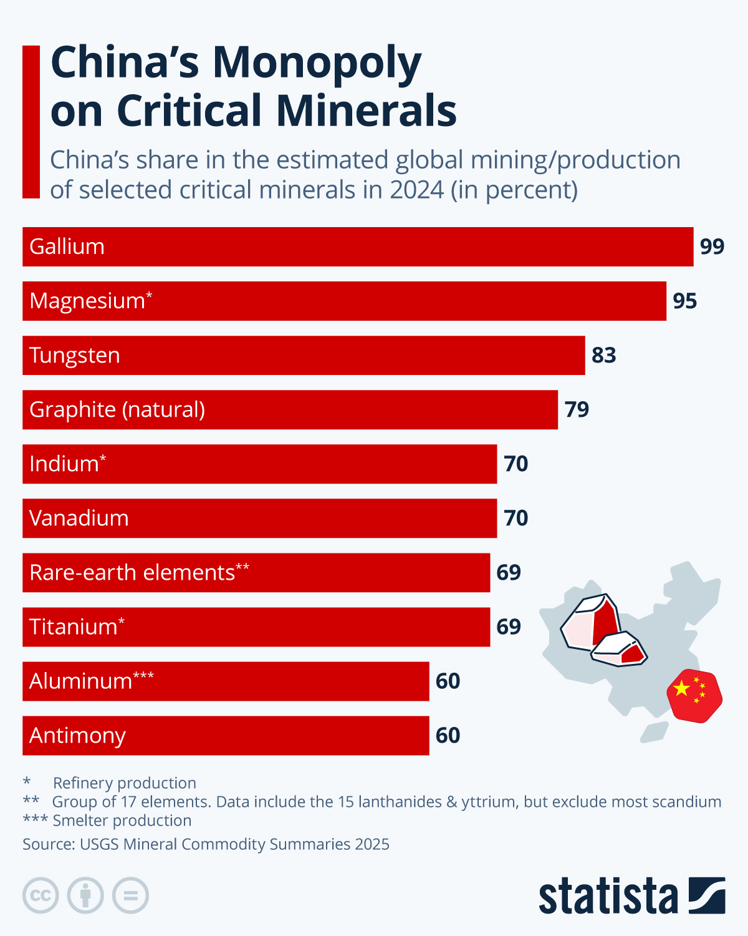
The escalation of geopolitical conflict between China and the U.S. surely comes at the cost of accelerating the transition to renewable energy, at least for those states willing to undertake this transformation. Will the consequence of geopolitical rivalry be, as Michael Klare suggests, a scalding planet?

Strategic Minerals, Industrial Policy, and Developmental Sovereignty
A central issue emerging from this new energy map is the political use of renewable resources as engines of national development.
Mexico and Chile have sought to assert national control over lithium production, with Mexico formally nationalizing lithium reserves and Chile pursuing public–private governance models. These strategies aim to secure value-added development in battery manufacturing, electric mobility, and domestic industrialization rather than remaining locked into raw-material exports.
Such policies challenge the principles of the Washington Consensus, which dominated global development policy from roughly 1980 to 2020. That framework emphasized privatization, trade liberalization, capital mobility, and minimal state intervention. Development was defined primarily as integration into global markets rather than national industrial strategy.
It is helpful here to recall a bit of historical context. The historical alternative to Washington Consensus was the New International Economic Order, a set of proposals formulated by the developing countries and approved by the UN General Assembly in 1974. The perspective of these countries was that barriers to development existed in terms of how the international economy was organized - mostly to benefit the developed countries. The developed countries responded, by the end of the decade, with the neoliberal consensus that faulted developing countries: it was their inefficiency and institutional weakness that blocked development and thus states should be restrained while market forces were amplified.
Defying the norms of the Washington Consensus historically exposed states to serious risks: capital flight, investor arbitration claims, credit downgrades, or trade retaliation. Today, however, the reemergence of industrial policy in the U.S., China, and the European Union has reopened the development debate. Delegates must consider:
- Should developing states be permitted greater policy space to guide industrial strategy?
- Can national resource control coexist with open markets?
- How can trade law be aligned with sustainable development?
- Who governs the renewable transition—and in whose interests?
The energy transition is thus also a conflict over development models. In contemplating these questions, delegates should take note of the development of state–based regulatory regimes for for critical renewable resources:
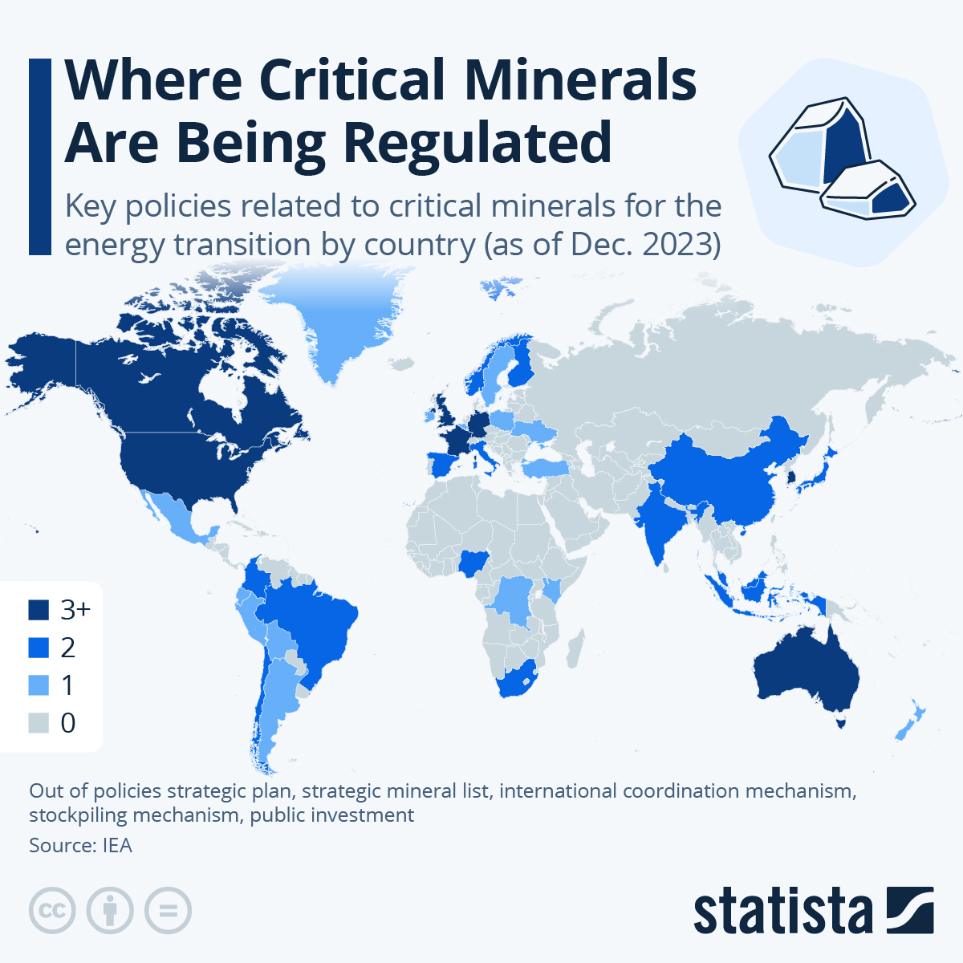

The United Nations and the Emergence of a Global Critical Minerals Regime
Recognizing the geopolitical stakes of renewable resources, the UN system has begun articulating a coordinated governance framework for critical minerals.
The United Nations Environment Programme (UNEP) has emphasized that the energy transition cannot succeed without addressing governance failure in mineral supply chains. Through an initiative led by the Secretary-General, UNEP and partner agencies have committed to building trust, reliability, and benefit-sharing across producer and consumer countries. UNEP frames mineral governance as essential to both the Paris Agreement and the Sustainable Development Goals:
To support a just energy transition and accelerate the achievement of the Paris and Sustainable Development Goals, UNEP and other UN agencies will work with producer and consumer countries to build trust, reliability, resilience, and benefit-sharing in critical mineral supply chains; and to support producer countries in developing productive, trade, and regulatory capacity for long-term sustainable development.
This work is reinforced by several complementary agencies:
UNDP (United Nations Development Program) focuses on governance capacity, institution-building, and equitable development. In the minerals sector, UNDP promotes policy frameworks that integrate environmental safeguards, local development planning, and participatory governance for communities affected by extraction.
UNCTAD (United Nations Conference Trade and Development) addresses mineral governance through trade, investment, and industrial policy. It has emphasized:
- reforming investment treaties that limit policy space,
- improving revenue transparency from extractive industries,
- and enabling value-added processing in producer countries rather than reinforcing export dependency.
UNIDO (United Nations Industrial Development Organization) supports industrial upgrading and value-chain integration. It advances policies aimed at:
- developing domestic manufacturing capacity,
- supporting technology transfer,
- and enabling developing states to climb renewable supply chains rather than remain exporters of raw materials.
Taken together, these initiatives signal the emergence of what may be described as a Global Critical Minerals Regime: an evolving international framework seeking to stabilize markets, prevent conflict, ensure ethical extraction, and reclaim development space for producer countries. An overview of what such a regime might look like is conveyed by the UN General Secretary’s UN Guidance on critical energy transition minerals. Delegates should review this report.
These prospective institutional structures will not eliminate U.S.–China rivalry. But it offers a set of global rules and institutional pathways that can potentially moderate competition, protect vulnerable populations, and promote sustainable growth.

Environmental Justice, Labor Rights, and Indigenous Protection
Mineral-based energy systems often reproduce older patterns of inequality:

- hazardous labor conditions,
- ecosystem destruction,
- indigenous dispossession,
- and corporate impunity.
A just energy transition requires more than green technology. It requires enforceable labor standards, environmental protections, and compensation mechanisms for communities harmed by extraction. Indigenous land rights must be respected, and food and water security protected. It also required a framework which not only protects local communities from the harm that can come from the extraction of the sustainable minerals, but also to enable them to lay claim to some share of the wealth that is created through these processes of extraction.
Because renewable minerals are global necessities, the committee must consider whether:
- binding international safeguards are needed,
- voluntary corporate standards are sufficient,
- or new compliance structures should be created within the UN system.

Governance Options for Delegates
- Multilateral Supply‑Chain Transparency: Create interoperable disclosure standards for origin, ESG metrics, and processing steps.

- Strategic Partnerships & Clubs: Form cooperative agreements linking producers, processors, and consumers to stabilize supply and prices.

- Sustainable Finance & De‑Risking: Develop green bonds, guarantees, and concessional finance for responsible mining and refining.

- Diversification & Stockpiles: Encourage regional refining hubs and maintain strategic reserves of key refined materials.

- Recycling & Circularity Mandates: Set collection targets, eco‑design requirements, and material‑recovery benchmarks.

- Development Compacts: Tie market access or financing to FPIC, benefit‑sharing, and local‑content strategies that build capacity.

- Dispute‑Resolution Mechanisms: Establish neutral forums for resolving contract, ESG, and cross‑border trade disputes.

- Emergency Coordination: Create protocols to manage acute supply disruptions without undermining climate goals.

Committee Directive and Guiding Questions:
Your mandate is to propose a framework (resolution or set of linked instruments) that secures mineral supply for the energy transition while advancing justice and avoiding destabilizing geopolitical rivalry.
• How will your framework diversify both mining and processing while keeping costs manageable?
• What minimum ESG and FPIC standards will be binding, and how will compliance be verified?
• How will producer states benefit—through royalties, equity, local processing, technology transfer, or development compacts?
• What finance and de‑risking tools will accelerate responsible projects in higher‑risk regions?
• How will recycling and circular‑economy measures reduce primary extraction over time?
• What emergency coordination measures will mitigate acute disruptions without fueling resource nationalism or rivalry?

Selected UN Bibliography
(Official UN and Multilateral Documents Only)

United Nations System
United Nations Secretary-General. 2023. A World Powered by Renewables: Secretary-General’s Remarks on Critical Minerals and the Energy Transition. New York: United Nations.
United Nations Secretary-General. 2023. Guidance on Critical Energy Transition Minerals for a Just and Sustainable Energy Transition. New York: United Nations.
United Nations Environment Programme (UNEP). 2023. Building Just and Sustainable Critical Mineral Supply Chains. Nairobi: UNEP.
United Nations Environment Programme (UNEP). 2023. Responsible Mining and Energy Transition Minerals. Nairobi: UNEP.
United Nations Development Programme (UNDP). 2023. Human Development Report 2023–24: Breaking the Gridlock. New York: UNDP.
United Nations Conference on Trade and Development (UNCTAD). 2023. Commodities and Development Report 2023. Geneva: UNCTAD.
United Nations Conference on Trade and Development (UNCTAD). 2022. World Investment Report 2022: International Tax Reforms and Sustainable Investment. Geneva: UNCTAD.
United Nations Industrial Development Organization (UNIDO). 2022. Industrial Development Report 2022. Vienna: UNIDO.
United Nations Industrial Development Organization (UNIDO). 2023. Industrializing in the Digital Age. Vienna: UNIDO.
United Nations Framework Convention on Climate Change (UNFCCC). 2015. The Paris Agreement. Bonn: UNFCCC Secretariat.

Colonial & Development Legacy
United Nations General Assembly. 1974. Declaration on the Establishment of a New International Economic Order. New York: United Nations.

