Convention on the Accountability of UN Peacekeepers
United Nations Department of Peace Operations

Luan Rushiti, Florida Gulf Coast University

- The Focus of this Topic
United Nations Peacekeeping operations are defined by their mandates and interpreted broadly by the global community as some sort of collective action scenario where everyone is agreed to the actions they are going to take on any given situation. However, the actual job of peacekeeping is heavily influenced by the actions taken by individual peacekeepers. Whether these people act in the interest of their legal mandate, or for some nefarious purpose, they are taking actions which shape the conditions on the ground where they are stationed. In recent years there have been many accusations against UN peacekeepers regarding the abuse of their power, and sex crimes and exploitation linked to members of UN peacekeeping forces. These accusations seriously undermine the legitimacy of not only the United Nations, but also of the member nations who contribute forces to UN Peacekeeping missions. If people are not held accountable for their actions, how can the United Nations justify its mandates and the actions it takes in the service of peace and justice worldwide? How can the UN enforce legal mandates when their members commit illegal acts? Is the United Nations above the purview of the law? These questions, along with many others, are at the heart of why this issue and conference are so important. Solving this issue requires that we not shy away from discussing criminal acts in their full detail. The stories of those who have been victimized by UN peacekeepers are just as important as those stories of individuals who have been victimized by belligerent regimes and terror groups. Accountability for all must be applied equally and without favor or blind eyes. The rights of victims must also be appropriately addressed. If adequate restitution is not given to the victims, through justice and requisite compensation, then the UN commitment to victims worldwide is undermined. The focus of this convention is to create an adequate system of accountability for perpetrators, while also ensuring that victims are protected and compensated appropriately.

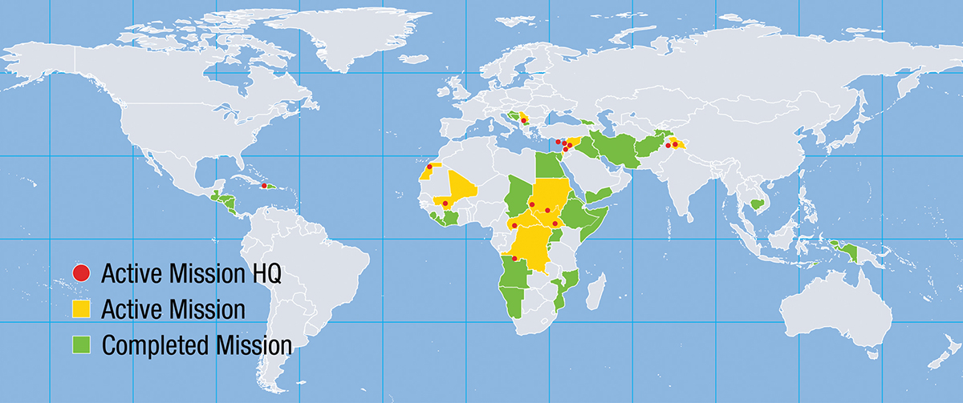
- The UN Peacekeeping Force and its Crimes
“This map shows 70 years of peacekeeping operations spanning across four continents.” Source: United Nations Peacekeeping
The United Nations Peacekeeping force consist of military, police, and civilian personnel. These peacekeepers are a volunteer force, donated by nations who willingly contribute their forces to peacekeeping operations. The United Nations does not have a dedicated standing army. The United Nations peacekeeping force has been deployed to many places. Currently, their active missions are mostly underway in Africa and the Middle East. These places have highly vulnerable populations, and criminal peacekeepers prey on this vulnerability. The most vulnerable people in these places are women and girls. The victims have faced rape, sexual slavery, human trafficking, and prostitution from criminal peacekeepers. The effects of peacekeeper crimes, according to Melanie O’Brien in her article Sexual Exploitation and Beyond, include the following:

“Peacekeepers engaging in sexual exploitation results in a proliferation of human trafficking and prostitution; the spread of sexually transmitted infections (including HIV/AIDS) amongst the local population, peacekeepers, and sending state populations; and even in abandoned ‘peacekeeper babies’. In addition, the commission of sexual exploitation and other sexual abuse has negative effects on the mission itself. Exploitative behavior creates mistrust amongst the local population of the peacekeepers, jeopardizing the elements of cooperation with and support of the local population, which are vital to the success of a peace operation” (O’Brien, p. 3-4).

The African missions of the United Nations peacekeepers have proven to be a hotbed of violations and violators. The brutality of peacekeepers in Africa has seriously damaged United Nations peacekeeping progress in these regions, such as the Democratic Republic of Congo, the Central African Republic and Burundi. These nations were already unstable to begin with, and the additional factor of criminal peacekeepers adds fuel to the raging fires. The number of allegations of sexual misconduct against military perpetrators was higher in 2016 than anytime in that past decade. In 2016 alone, 103 allegations against peacekeepers were reported to field missions. By 2024, the number of allegations of peacekeeper misconduct surpassed 100, for the third time in a decade.

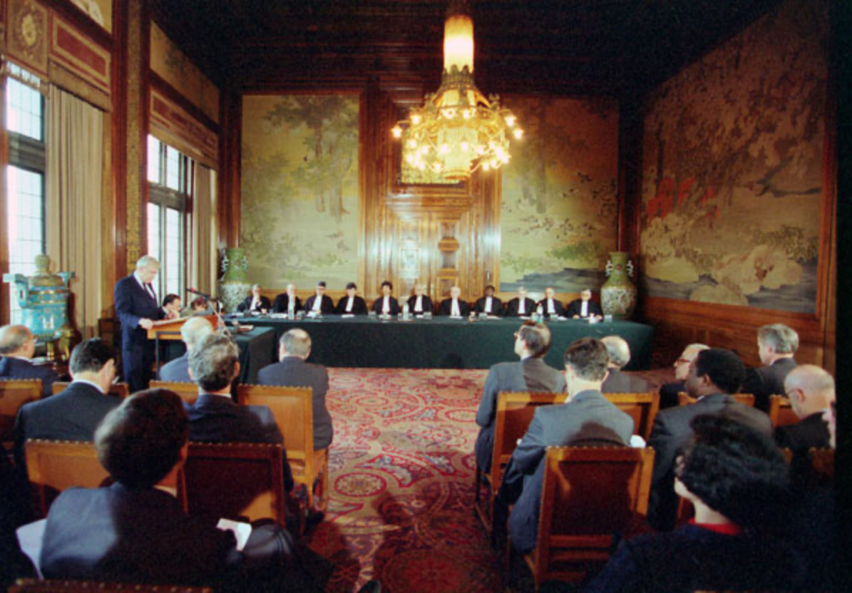
- Systems of Accountability for UN Peacekeepers and Commitment to Victims
“17 November 1993 - Inauguration of the International Criminal Tribunal for the former Yugoslavia, Peace Palace, The Hague, The Netherlands.” Source: Audiovisual Library of International Law
The United Nations began to take serious actions to curtail sexual abuse committed by peacekeepers in the early 2000s by commissioning reports and investigating claims made by other committees such as UNHCR. In 2006, the United Nations instituted its “zero-tolerance policy” towards criminal peacekeepers. In 2009, the United Nations expanded its commitment to the zero-tolerance policy through Resolution 1888, which created the United Nations Special Representative on Sexual Violence in Conflict. In 2016, there was a trust fund established by the United Nations to provide support to victims through specialized services including legal, medical (with support to ‘peacekeeper babies’ as well), and organization/streamlining of complaints. Currently, the United Nations provides support to victims of criminal peacekeepers and has a “putting victims first” approach. According to Kakule Kalwahali’s article The Crimes Committed by UN Peacekeepers in Africa, the scope of personnel immunity is not absolute:
“The personnel of UN peace operations are not absolutely immune from legal criminal liability since their immunity is functional, i.e. immunity ratione materiae, which is not meant to protect private interests. Peacekeepers, therefore, cannot actually assert immunity protections when they commit serious violations of human rights which fall outside the scope of their official duties, and most crimes by peacekeepers undoubtedly constitute, one one way or another, violations of human rights” (Kalwahali, p. 160).
How come there are not prosecutions if they have no legal immunity? Well, after the peacekeepers are repatriated to their home nations, said nations are unwilling to carry out prosecutions of them and their crimes. Another factor is the United Nations Secretary General since the office does not immediately waive immunity for civilian peacekeepers.

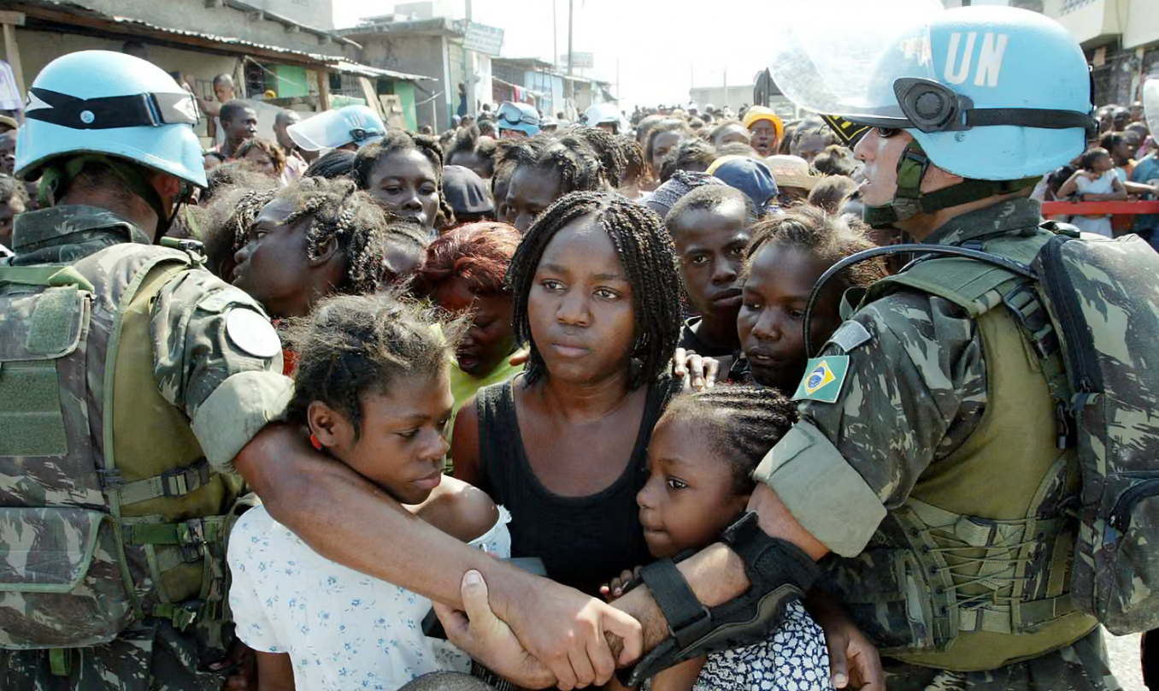
- Challenges to Accountability for UN Peacekeepers and Lacking Commitment to Victims
“NGOs say a mishmash of reporting mechanisms discourages victims making sexual assault allegations against UN peacekeepers.” Source: The Guardian, Eduardo Munoz/REUTERS
Accountability is the cornerstone upon which the United Nations was founded. The Universal Declaration of Human Rights stands as a beacon of standards which every human is afforded, in an ideal world. The United Nations exists to champion these standards and hold people accountable; however, efforts at holding people accountable to United Nations/International standards have been mixed. Since the United Nations peacekeeping force is contribution based, with nations volunteering their troops to missions, prosecution of criminal peacekeepers must be pursued by individual nations. At the current time, the most the United Nations Department of Peace Operations can do is investigate, then reprimand an individual for their conduct, ban them from future peacekeeping operations, and repatriate them back to their home nations. According to Alexandra Daukaus in her article United Nations Peacekeepers Perpetration of Sexual Exploitation and Abuse, regarding the commitments to victims she says the following:
“The United Nations’ efforts to address sexual exploitation and abuse have been largely centered on its Trust Fund in Support of Victims of Sexual Exploitation and Abuse. Within this approach, the Trust Fund is designed to specifically address the needs of victims of SEA within a victims’ rights-based approach. However, when examined through a victims’ rights lens, the Trust Fund falls short of both its stated aims and of meeting victims’ needs” (Daukaus, p. 60).
The first reason why the trust fund falls short is because the funding doesn’t go directly to victims, it is instead used to fund programs which may (or may not) help the victims. The second reason is that funding is wasted on programs which have no connection to preventing sexual exploitation. Examples include classes for illiterate individuals and training in textile work and culinary arts. The thinking here is that they are training people to be self reliant and provide for themselves through these skills; however, they are not addressing the inherent imbalance of power between the peacekeepers and the general public in these areas. Peacekeepers have access to the aid, and they can allocate it as they see fit when they are deployed, potentially retaliating against certain individuals.

- Charge of this Committee
Your goals, as representatives to the United Nations on behalf of your respective nations, is to produce a resolution which addresses the issues laid out in this convention paper. The resolution should address preventative measures, potential consequences, and restitution. First, establish common values and norms between your nations regarding this topic that all will consent to, acknowledge, and work off of. Next, establish the institutional frameworks you want to see. Set up chains of responsibility by determining who will be held accountable for crimes: commanding officers who stand by and do nothing, the criminal peacekeepers themselves, etc. Determine what international body will have jurisdiction over prosecutions of criminal peacekeepers: the International Criminal Court, a separate dedicated tribunal, the nation of origin (the one who sent the peacekeeper), or the nation of station (the nation where the crime took place), or a combination. What investigative mechanisms should be implemented into the UN Department of Peace Operations? Should there be a permanent agency within the department dedicated to internal investigations? Can it function under the UNDPO, or should it be a separate institution for the whole UN? How can this department protect victims who come forward? What whistleblower and witness protections policies and programs should there be? Should the peacekeeper training program be altered to incorporate preventative measures? How will the individual victims be helped? How will the communities that these victims belong to be reassured? This is an international issue; it thus warrants an international response. Remember: you are first establishing values and norms, and then you are setting up institutions.

- Recommended Readings
Daukaus, Alexandra. 2024. "United Nations Peacekeepers Perpetration of Sexual Exploitation and Abuse: Examining the United Nations Commitment to Victims’ Rights." Order No. 31235471, Harvard University. https://www.proquest.com/dissertations-theses/united-nations-peacekeepers-perpetration-sexual/docview/3050812328/se-2.

Giles, Shayna Ann. 2017. "CRIMINAL PROSECUTION OF UN PEACEKEEPERS: WHEN DEFENDERS OF PEACE INCITE FURTHER CONFLICT THROUGH THEIR OWN MISCONDUCT." American University International Law Review 33 (1): 147-185. https://www.proquest.com/scholarly-journals/criminal-prosecution-un-peacekeepers-when/docview/1987343641/se-2.

Kalwahali, Kakule. 2013. "The Crimes Committed by Un Peacekeepers in Africa: A Reflection on Jurisdictional and Accountability Issues." Order No. 32025504, University of South Africa (South Africa). https://www.proquest.com/dissertations-theses/crimes-committed-un-peacekeepers-africa/docview/3224598920/se-2.

Laurence, Marion, Emily Paddon Rhoads, and Sarah von Billerbeck. 2025. “The Scope for Agency and the Role of Individuals in UN Peace Operations.” International Peacekeeping (13533312) 32 (2): 161–74. doi:10.1080/13533312.2025.2477146.

Ndulo, Muna. 2009. “The United Nations Responses To The Sexual Abuse And Exploitation Of Women And Girls By Peacekeepers During Peacekeeping Missions.” Berkeley Journal of International Law 27 (1): 127–61. https://research.ebsco.com/linkprocessor/plink?id=b881346b-df0d-36ea-a842-93361d838527.

O’Brien, Melanie. 2011. “Sexual Exploitation and Beyond: Using the Rome Statute of the International Criminal Court to Prosecute UN Peacekeepers for Gender-Based Crimes.” International Criminal Law Review 11 (4): 803–27. doi:10.1163/157181211X587661.

Singh, Kirandeep, Amresh Kumar Gauda, and Ajit Kumar. 2025. “United Nations Peacekeeping Operations and Budgeting: Analysis and Challenges.” Cuestiones de Fisioterapia 54 (3): 2615–21. https://research.ebsco.com/linkprocessor/plink?id=d6a3f2ae-8967-3a24-9b4b-8edb032b1343.

van Leeuwen, Jayden. 2019. “Addressing the Gap: Accountability Mechanisms for Peacekeepers Accused of Sexual Exploitation and Abuse.” Victoria University of Wellington Law Review 50 (1): 135–56. doi:10.26686/vuwlr.v50i1.5556.

